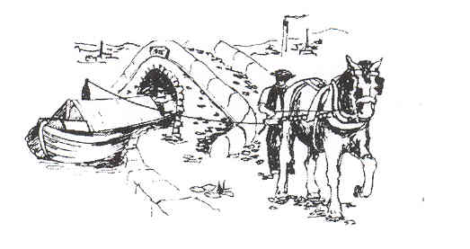
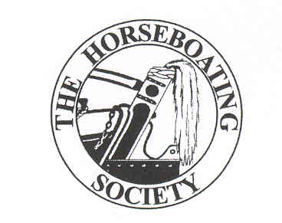
Training and Familiarisation Days in 2008
Preserving and Promoting Horseboating
www.horseboating .org.uk

The Horseboating Society is planning to offer several dates in 2008 as training and familiarisation days to fulfil our objective of “the training of crew and horses to acquire the skills necessary for horse boating”.

Bonny the Boathorse is due to foal in June 2008 so will not be available for much boating. Queenie was injured when coming round from anaesthetic in the recovery room of the Liverpool equine hospital after colic surgery and so is unavailable for boating. Therefore there is an urgent need to train one or more boathorses for HBS to continue its work.

Members are invited to join in as many training days as they can manage, both to help train the horse/s and to further their own skills. Many weekend dates from Jan 19 to April 27 will be on offer. The dates chosen will be those where we have a minimum crew of 4, preferably 6, and not on dates taken by other activities like the HBS AGM (March 16). Ice will also prevent use of a boat to prevent damage to wooden hulls. It might be possible to do some horse-handling only on such days.

Most training will take place with Maria, flagship of the Horseboating Society, by kind permission of her owners the Ashton Packet Boat Co.
She is based on the Ashton Canal, 5 miles from Manchester, and training will have a base of the Portland Basin Museum for toilets, café etc. Some dates will be with Gifford, owned by the Boat Museum Society, and based at the National Waterways Museum, Ellesmere Port.

Training will cover skills of horse boating in a structured and methodical learning manner, often not possible on journey days. The society hopes to offer accredited training eventually. A record will be kept of the attendance of HBS members and skills covered. Sessions may include: Preparing horse and boat for a journey, setting off, navigation, stopping, winding, reversing, use of T-stud or “bridle”, locks. More advanced training will also be developed eg use of an overhead line with 2 boats.

Please fill in the form to indicate your interest and availability for training sessions. Remember to check if the date is going ahead before you travel.

